BDC 001 INTRENAL STRUCTURE AND FIELD MAPPING

CALL FUNCTION 'GUI_UPLOAD'  
  EXPORTING  
    FILENAME                      = GV_FILE  
   FILETYPE                      = 'ASC'  
   HAS_FIELD_SEPARATOR           = 'X'  
*   HEADER_LENGTH                 = 0  
*   READ_BY_LINE                  = 'X'  
*   DAT_MODE                      = ' '  
*   CODEPAGE                      = ' '  
*   IGNORE_CERR                   = ABAP_TRUE  
*   REPLACEMENT                   = '#'  
*   CHECK_BOM                     = ' '  
*   VIRUS_SCAN_PROFILE            =  
*   NO_AUTH_CHECK                 = ' '  
* IMPORTING  
*   FILELENGTH                    =  
*   HEADER                        =  
  TABLES  
    DATA_TAB                      = GT_ITAB  
* CHANGING  
*   ISSCANPERFORMED               = ' '  
 EXCEPTIONS  
   FILE_OPEN_ERROR               = 1  
   FILE_READ_ERROR               = 2  
   NO_BATCH                      = 3  
   GUI_REFUSE_FILETRANSFER       = 4  
   INVALID_TYPE                  = 5  
   NO_AUTHORITY                  = 6  
   UNKNOWN_ERROR                 = 7  
   BAD_DATA_FORMAT               = 8  
   HEADER_NOT_ALLOWED            = 9  
   SEPARATOR_NOT_ALLOWED         = 10  
   HEADER_TOO_LONG               = 11  
   UNKNOWN_DP_ERROR              = 12  
   ACCESS_DENIED                 = 13  
   DP_OUT_OF_MEMORY              = 14  
   DISK_FULL                     = 15  
   DP_TIMEOUT                    = 16  
   OTHERS                        = 17  
          .  
IF SY-SUBRC <> 0.  
* Implement suitable error handling here  
ENDIF.  
  
  
perform open_group.  
  
LOOP AT GT_ITAB INTO GS_ITAB.  
 perform bdc_dynpro      using 'SAPMV13A' '0100'.  
  
 perform bdc_field       using 'BDC_CURSOR'  
                               'RV13A-KSCHL'.  
 perform bdc_field       using 'BDC_OKCODE'  
                               '=ANTA'.  
 perform bdc_field       using 'RV13A-KSCHL'  
                               'YBPR'.  
 perform bdc_dynpro      using 'SAPLV14A' '0100'.  
 perform bdc_field       using 'BDC_CURSOR'  
                               'RV130-SELKZ(02)'.  
 perform bdc_field       using 'BDC_OKCODE'  
                               '=WEIT'.  
 perform bdc_field       using 'RV130-SELKZ(01)'  
                               ''.  
 perform bdc_field       using 'RV130-SELKZ(02)'  
                               'X'.  
 perform bdc_dynpro      using 'SAPMV13A' '1005'.  
 perform bdc_field       using 'BDC_CURSOR'  
                               'KONP-KONWA(01)'.  
 perform bdc_field       using 'BDC_OKCODE'  
                               '/00'.  
 perform bdc_field       using 'KOMG-VKORG'  
                                GS_ITAB-VKORG.  
*                               '0001'. "-----------  
 perform bdc_field       using 'KOMG-VTWEG'  
                                GS_ITAB-VTWEG.  
*                               '01'.   "-------  
 perform bdc_field       using 'KOMG-KUNNR'  
                                GS_ITAB-KUNNR.  
*                               '800026'. "---------  
 perform bdc_field       using 'KOMG-MATNR(01)'  
                                GS_ITAB-MATNR.  
*                               'T-F299'. "--------------  
 CONDENSE GS_ITAB-KBETR.  
 perform bdc_field       using 'KONP-KBETR(01)'  
                                GS_ITAB-KBETR.  
*                               '             150'. "-----------  
 perform bdc_field       using 'KONP-KONWA(01)'  
                                GS_ITAB-KONWA.  
*                               'INR'.      "------------  
 perform bdc_dynpro      using 'SAPMV13A' '1005'.  
 perform bdc_field       using 'BDC_CURSOR'  
                               'KOMG-MATNR(01)'.  
 perform bdc_field       using 'BDC_OKCODE'  
                               '=SICH'.  
 perform bdc_transaction using 'VK11'.  
  
 CLEAR : GS_ITAB.  
ENDLOOP.  
perform close_group.

USING CALL TRANSACTION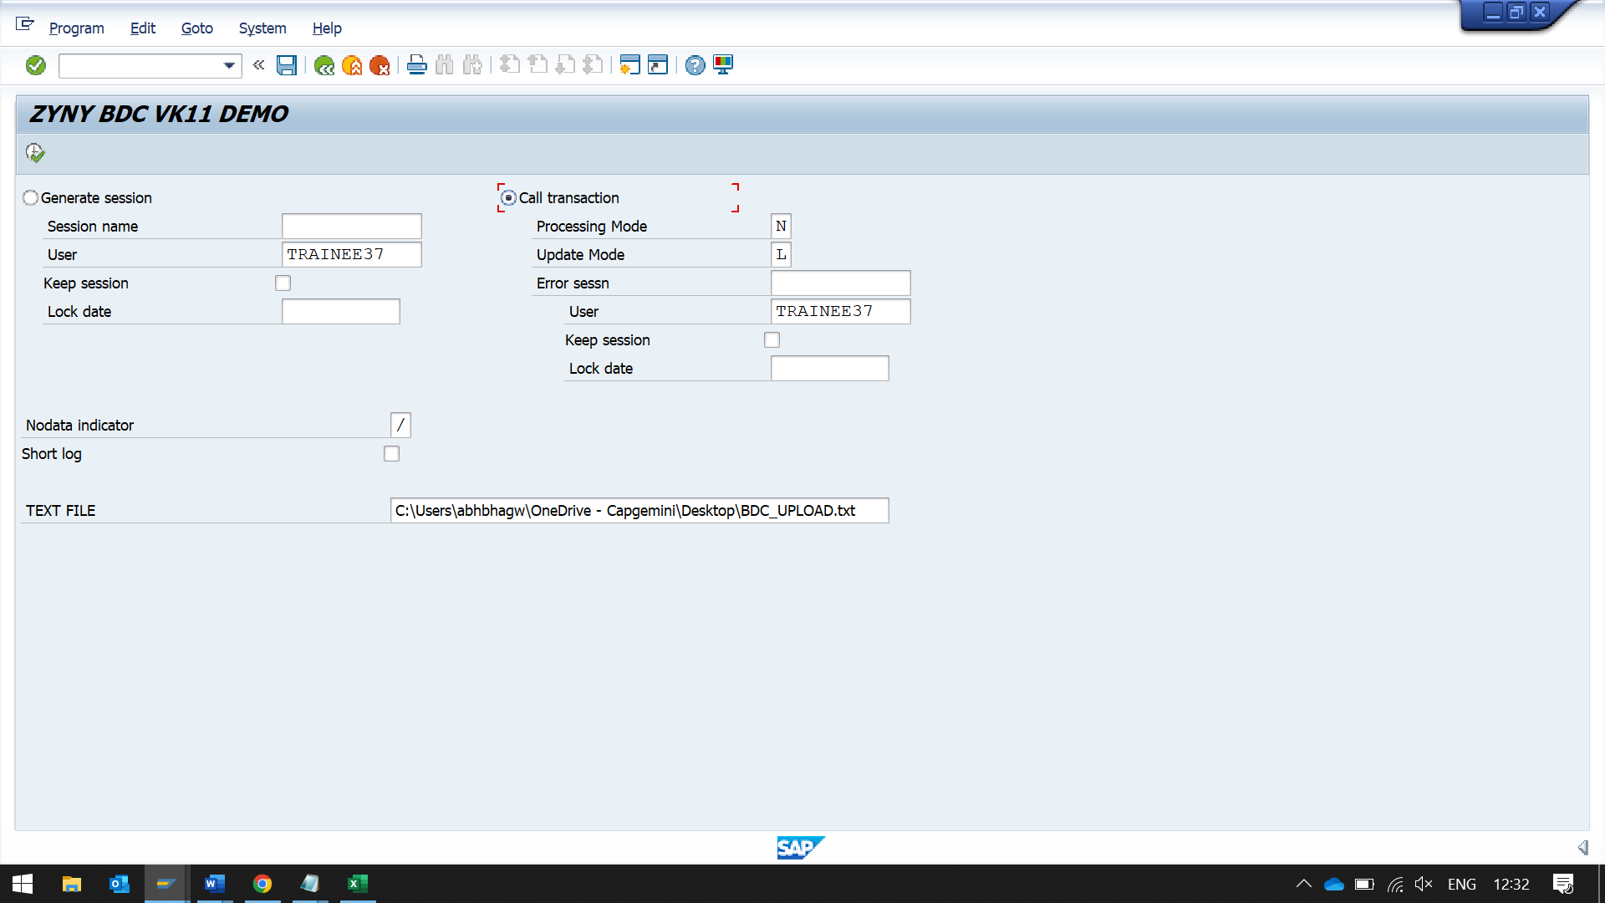

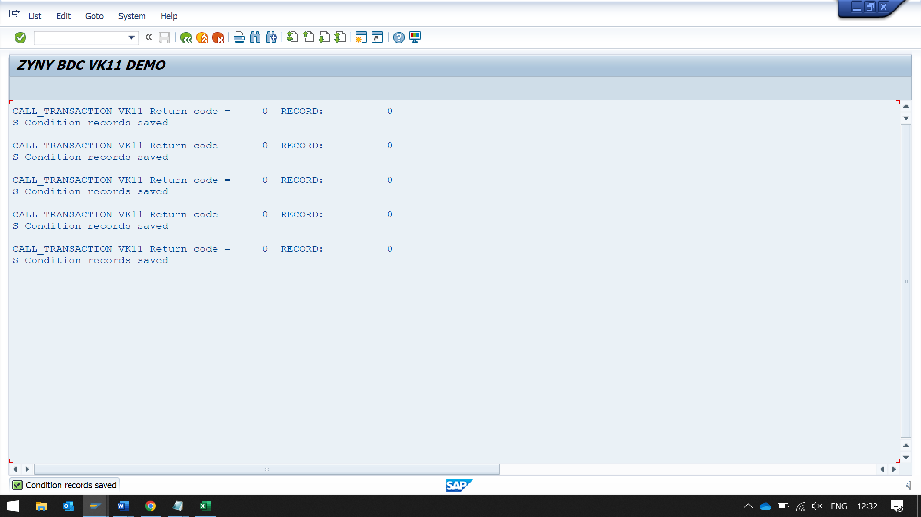

BY USING SESSION

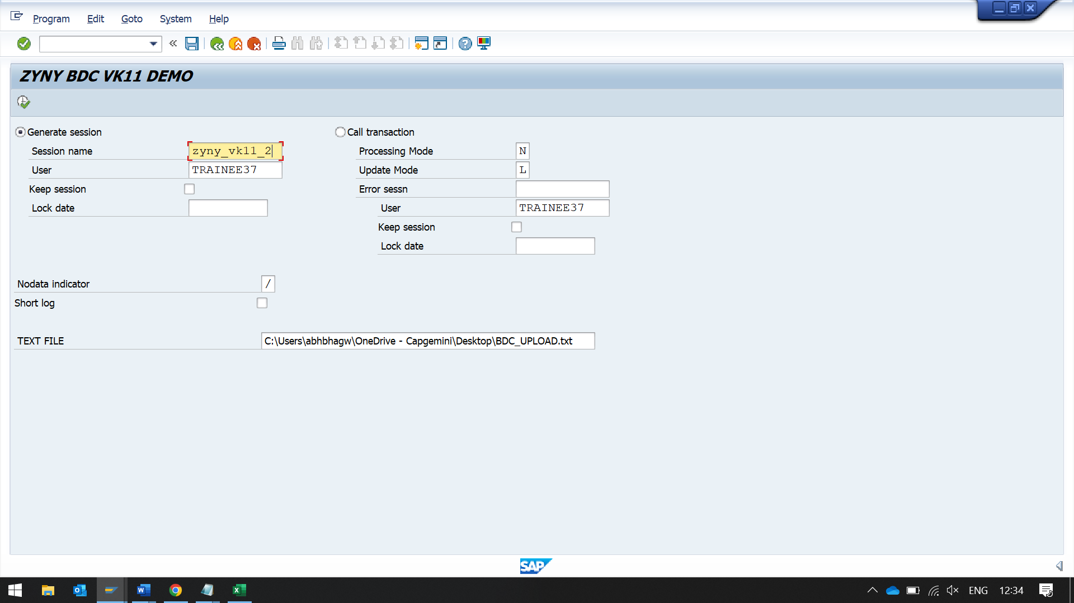

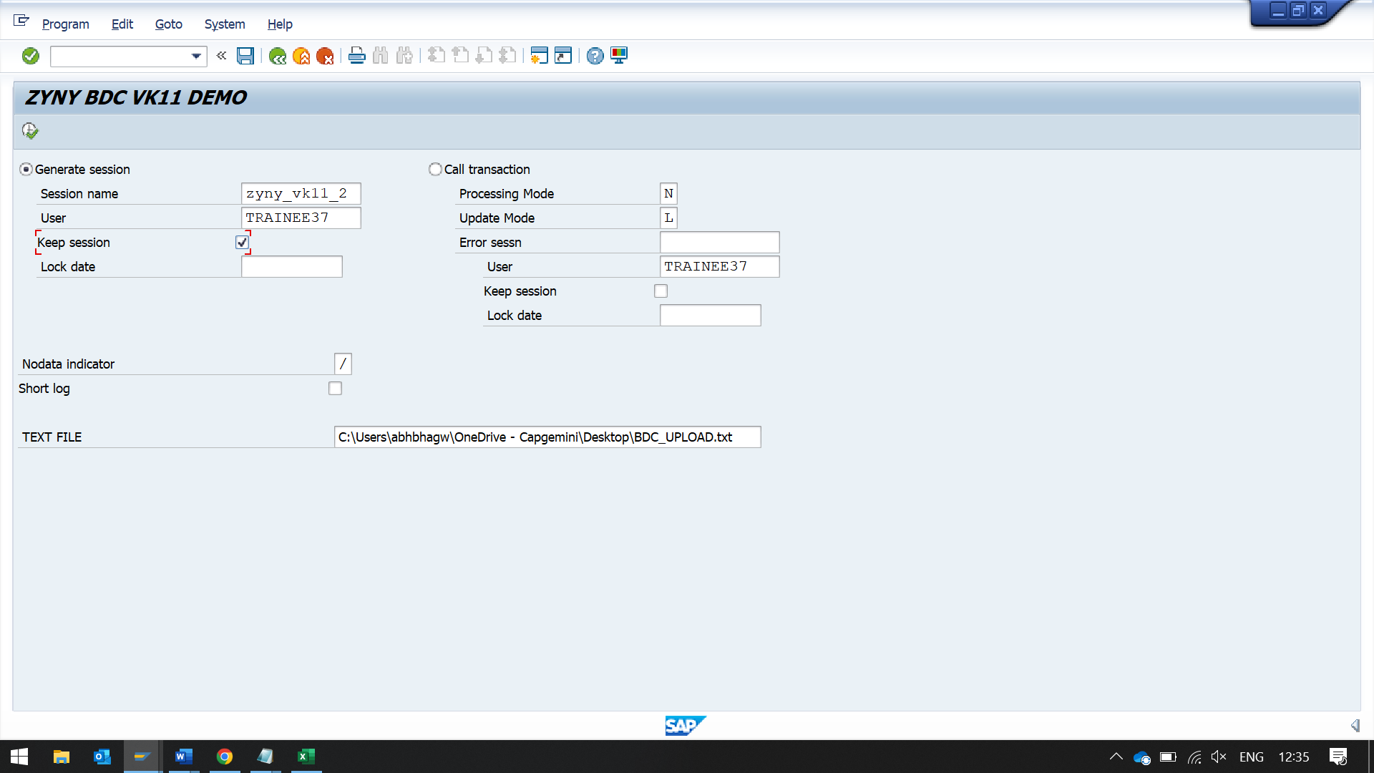

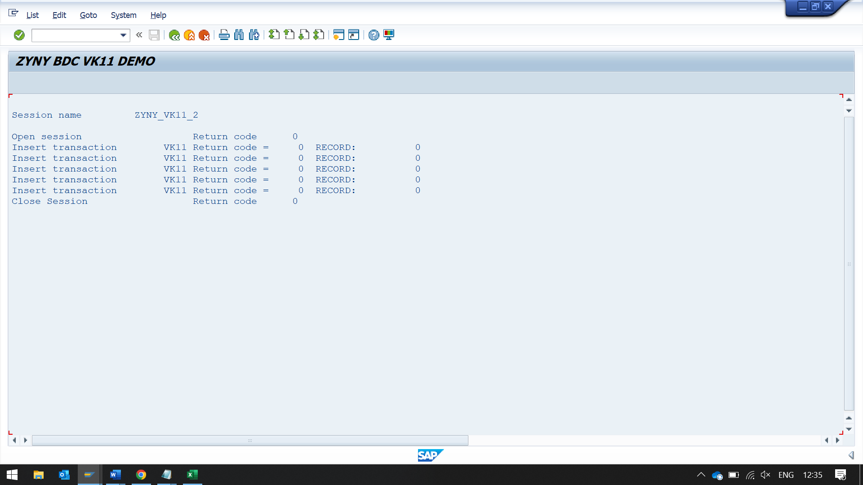

GO TO SM35 TO SEE THE SESSION

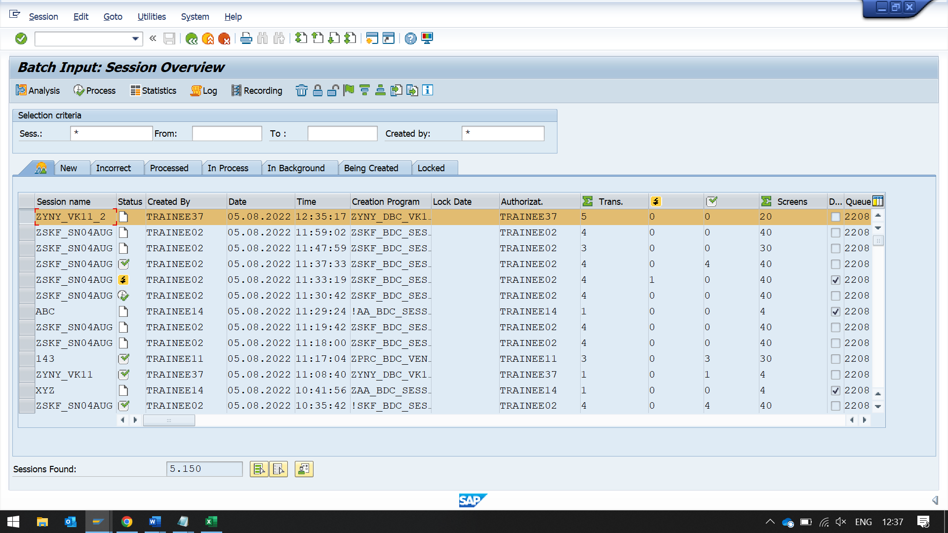

SELECT THE SESSION

CLICK ON PROCESS

